# 接口返回数据说明

* 结果状态

1. code :9 成功，
2. -1 失败
3. 0 session过期（需要重新登陆,弹出登陆界面）
4. 2 权限不足需要购买权限
5. 1 余额不足要充值（需要弹出充值界面）

* 部分接口需要传入token参数，同时必须在http 的头部增加参数appId：加密（loginName）具体算法iOS 跟 android 不一致
* 任何接口后面接个时间戳参数
* result ：返回数据

{

"code":9,// 结果状态

"result"：{ //返回数据

..... //此处省略

}

}

# 获取版本接口

**GET**

http://localhost:8080/express/rest/version?deviceType=android

{"code":9,"result":{"version":"20161115.1.0beta","isRequire":"1","remarks":"测试","downloadPath":"app/android/express.apk"}}

返回结果说明：isRequire 是否必须升级 remarks 升级内容 downloadPath:升级地址

完整下载地址 http://localhost:8080/app/android/express.apk

# 注册接口

**POST**

http://localhost:8080/express/rest/register

参数

{

"loginName":"test4",

"name":"xu",

"phone":"1111111111",

"userType":"3",//2 普通用户, 3快递员

"serviceArea":"000000000000001" //普通用户不需要填，快递员时必填,

" verificationCode":"123456"//短信验证码

}

# 注册验证码接口

**GET**

http://localhost:8081/express/rest/registerCode?mobile=12111111111

{"code":9,"result":"613414"}

# 忘记密码验证码接口

POST

http://localhost:8081/express/rest/forget?mobile=12111111111

# 重置密码接口

POST

http://localhost:8081/express/rest/resetPwd

{

" password":"",

" mobile":""

" verificationCode":""

}

# 登陆接口：

**POST**

http://localhost:8080/express/rest/login

{

"loginName":"12111111111",

"password":"123456",

"deviceType":"android",

"deviceNo":"100000000000000000000"

}

返回结果：

{"code":9,"result":{"token":"85e9aa9754fc49f9a9e6b65d05d120ebsD9SmTavBgBuOYCv4xNR2xGZyeJoxWU31","userType":"1", **"wifiUpload":"0","name":"abc"**

}}

**返回结果说明：**

token : 缓存起来，除非登出时清除,重新登陆时更新，以后部分请求需要用到

userType ：用户类型

**wifiUpload：0任何网络快递单图片多自动上传 1 快递单图片只在wifi下自动上传**

**name:用户昵称**

# 登出接口

**POST**

http://localhost:8080/express/rest/logout?token=ec1c8cb8317f4c93baf8c6446f2829fcr0jFnG3W9tjzLVJ6t38ijIEBgWf7OJqdm

# 快递单查询接口

**GET**

http://localhost:8080/express/rest/image/find?token=413fab41db6b4f58866e86ddff83f25aIbMyzckUZ2OVr4n4bF6rhfZXlN9m0ZUz4&no=58&pageNo=1&date=2016-02-01&code=1234&expressType=1

# 快递单图片上传接口

**GET**

http://localhost:8080/express/rest/image/upload?token=413fab41db6b4f58866e86ddff83f25aIbMyzckUZ2OVr4n4bF6rhfZXlN9m0ZUz4&expressType=?&expressNo=?&sender=?&receiver=

# 图片地址

**GET**

http://localhost:8080/images/ + 返回数据的地址

条形码上传:

**POST**

http://localhost:8080/express/rest/barcode/add?token=xxxx

body中参数:

["xx","dd","cc"]

成功 code :9

失败:code :-1 result:失败的索引数组，如 [0,1,5]

# 用户信息接口

http://localhost:8081/express/rest/user/info?token=15b9f07789bb40208cc7e6291026ab38zbSml0Ajx7WqySgVaOy0O2FXRT3x11L3u

{"code":9,"result":{"name":"xu","phone":"1111111111","userPhoto":null,"commonAccount":0.00,"installmentAccount":0.00,"creditAccount":200.00,"creditLimit":200.00,"cashAccount":0.00}}

# 修改密码接口

POST

http:// localhost:8080/express/rest/user/ updatePwd

{

" password":"",

" oldPassword":""

}

# 修改WIFI上传状态

*POST*

http:// localhost:8080/express/rest/user/ setWifiUpload?token=xxx

参数 ：1 （只在wifi下上传） 0 （任何情况多上传）

用户推广扫码接口

*POST*

http:// localhost:8080/express/rest/user/ setWifiUpload?token=xxx

参数：扫到的二维码

# 上传头像接口

POST

http:// localhost:8080/express/rest/user/ uploadHeaderImage?token=xxx

# 获取广告接口

GET

http:// localhost:8080/express/rest/ads/ avaiable

# 获取关于我们信息接口

GET

http://localhost:8081/express/rest/company

# 2017-02-03

# 区域价格查询接口

GET

http://localhost:8081/express/rest/user/area

{"code":9,"result":[{"createDate":null,"userId":null,"areaId":"110100","areaName":"北京","price1":null,"price2":null},{"createDate":null,"userId":null,"areaId":"310100","areaName":"上海","price1":null,"price2":null}]

# 区域价格保存接口

POST

http://localhost:8081/express/rest/user/area/save

参数：[{"areaId":"110100","price1":2,"price2":1.5},{"areaId":"310100","areaName":"上海","price1":8,"price2":0}]

## 根据父节点查询子区域

GET

http://58.220.216.74:82/express/rest/config/area/get?parentId=110100

参数说明:parentId可以为空，空时为第一级区域

# 点击区域编辑时的接口

get

http://58.220.216.74:82/express/rest/config/area/edit?areaCode=110100_110101

参数说明:areaCode 可以为空，为空时第一次编辑

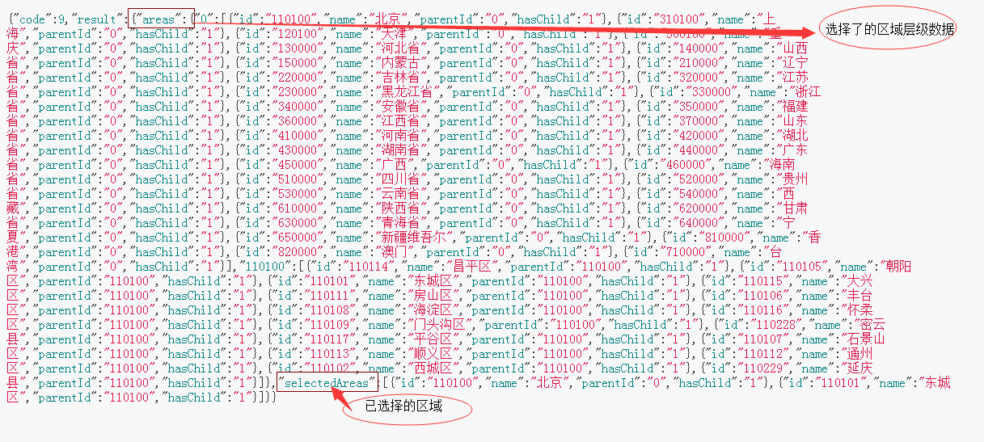

## 下单接口

POST

http://localhost:8081/express/rest/order/save

参数：

{

"submitType": "1", //1 保存 2保存且发布

"order": {

"id": "d607db69febe4a5db206edd4cbc15bc7",//编辑时存在

"serviceTime": "2017-02-10 11:15",//取件时间（必填）

"remarks": "不要忘记哦1",//备注 （非必填，100个字符以内）

"isInsurance": "1",//是否保价

"insuranceMoney": 1011.00,//保价金额，保价时必须大于0

"isArrivePay": "1",//是否到付 0 否 1是

"sendAddress": "江苏省苏州市工业园区",//寄件人地址

"sendDetailAddress": "国际科技园1910d99dd1",//寄件人详细地址（必填 100个字符以内）

"sendAreaCode": "1_2_31",//寄件人区域CODE，已下划线分隔（必填）

"sender": "张三1",//寄件人姓名（必填，50个字符以内）

"senderPhone": "15111111112",//寄件人联系方式（必填，50个字符以内） "receiveAddress": "江苏省无锡市工业园区",

"receiveDetailAddress": "国际科技园1910d99dd1",（100个字符以内）

"receiveAreaCode": "1_3_2",//收件人区域CODE，已下划线分隔（必填）

"receiver": "李四1",//收件人（必填，50个字符以内）

"receiverPhone": "0513-24255551",//收件人联系方式（必填，50个字符以内）

"isAgentPay": "0",//是否代收货款

"agentMoney": 100.00,//是，则必须大于0

"thingDesc": "衣服2",//物品描述，物品内容 大小等（必填 100个字符以内）

"weight": 2, //重量，必须以0.5为间隔（必填）

"expressCompany":"1"//快递公司(可选 可不选)

}

}

调试数据：

{

"submitType": "2",

"order": {

"serviceTime": "2017-02-10 11:15",

"remarks": "不要忘记哦1",

"isInsurance": "1",

"insuranceMoney": 1011,

"isArrivePay": "1",

"sendAddress": "江苏省苏州市工业园区",

"sendDetailAddress": "国际科技园1910d99dd1",

"sendAreaCode": "1_2_31",

"sender": "张三1",

"senderPhone": "15111111112",

"receiveAddress": "江苏省无锡市工业",

"receiveDetailAddress": "园区国际科技园1910d99dd1",

"receiveAreaCode": "1_3_2",

"receiver": "李四1",

"receiverPhone": "0513-24255551",

"isAgentPay": "0",

"agentMoney": 100,

"thingDesc": "衣服2",

"weight": 2

"expressCompany":"1"

}

}

## 快递单数据查看或者编辑

GET

http://localhost:8081/express/rest/order/get?id=9ced257e615443abb0043733dd3e921a

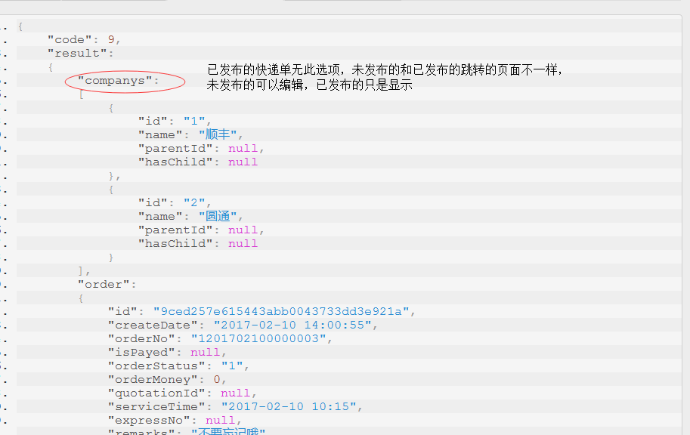

注意:orderStatus 1:未发布 2 已发布

## 快递公司查询接口

GET

http://localhost:8081/express/rest/config/company

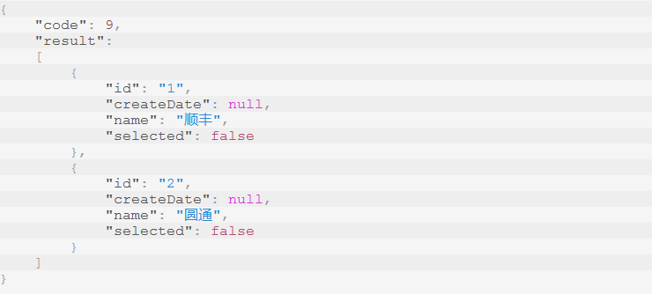

## 订单查询接口

GET

http://localhost:8081/express/rest/order/find?keyword=1&pageNo=1&token=c159e9df2d154f07a6f2342a19ea2834peYyb424ct18B6u22AW6uRdRRB7xVLy1b&orderStatus=

说明：

下单页面：

orderStatus ：

1. 空 ==所有

2. 1 == 未发布

3. 2 == 已发布

接单页面：

orderStatus：

1. 空 或2 ==待报价

2. 3 == 已报价

## 支付宝支付信息接口

GET

http://localhost:8081/express/rest/pay/alipay/get

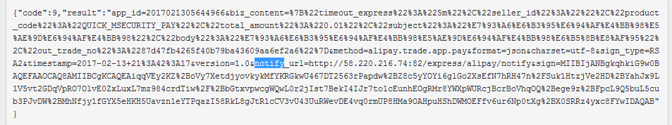

## 支付回调接口

POST

http://localhost:8081/express/rest/pay/log/save

参数

{"content":"支付宝返回结果"}

## 2017-02-21

# 下单页面初始化接口

Get

http://localhost:8081/express/rest/quotation/init

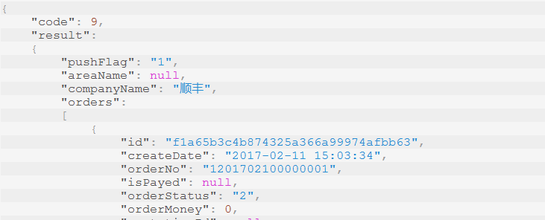

## 递员快递公司设置和服务区域设置接口

GET

http://localhost:8081/express/rest/user/service/get

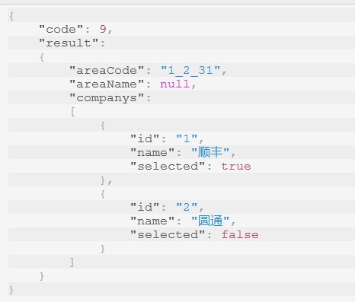

## 递员快递公司设置和服务区域保存接口

post

http://localhost:8081/express/rest/user/service/save

{

"companyId":"2",

"areaCode":"1_2_31",

"areaName":"casada"

}

## 推送打开和关闭接口

POST

http://localhost:8081/express/rest/user/push/open

http://localhost:8081/express/rest/user/push/close

## 快递单报价接口

POST

http://localhost:8081/express/rest/quotation/save

{

"insuranceMoney":1,

"expressMoney":10.00,

"orderId":"08f531947bda4bf1ac1f28162d26874b",

"remarks":"ceshi"

}

## 普通账户余额接口

GET

http://localhost:8081/express/rest/user/account/common

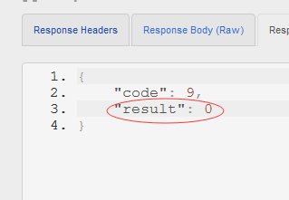

## 快递单报价单查询接口

http://localhost:8081/express/rest/order/quotations?id=08f531947bda4bf1ac1f28162d26874b

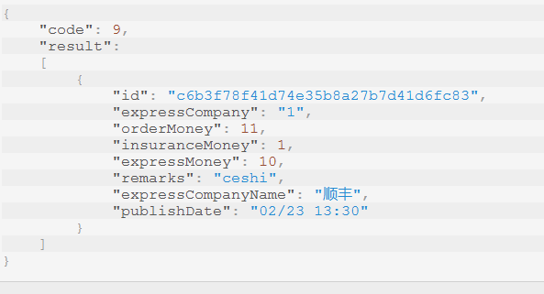

## 充值列表接口

GET

http://localhost:8081/express/rest/recharge/list

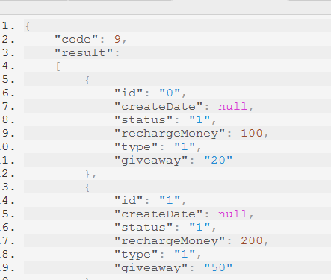

## 订单取消发布接口

POST

http://localhost:8081/express/rest/order/cancel?id=08f531947bda4bf1ac1f28162d26874b

# 2017-03-05

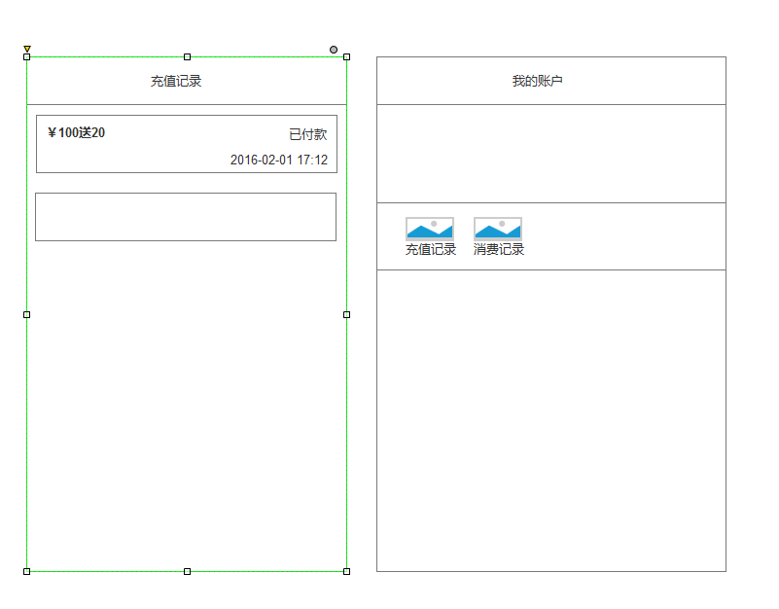

## 充值接口

Post

http://localhost:8081/express/rest/recharge/add

{

"payType":2 //2 支付宝 3 微信

"rechargeId":"0" //充值方式ID

}

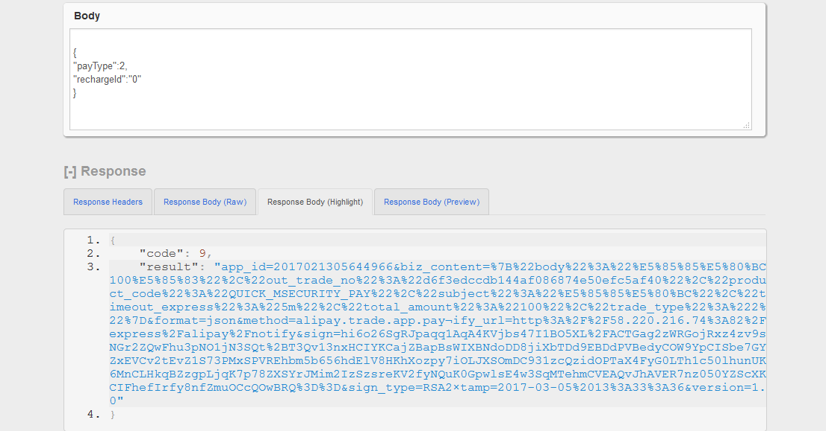

## 充值列表接口

GET

http://localhost:8081/express/rest/recharge/flow?pageNo=1

